Requirement Analysis
Data Flow Diagram & User Stories
Date | 04 September 2026
Student Name | Pulibanti Tejavani
Project Name | Metro Ticket Generating System
Maximum Marks

Logical Data Flow
Step | Flow
1 | Passenger opens the ServiceNow Service Portal.
2 | Passenger selects the Book a Metro Ticket service.
3 | Portal displays the ticket-booking form with journey and passenger variables.
4 | Passenger selects starting station, destination, journey type, passenger count, and payment mode.
5 | Catalog Client Scripts and UI Policies validate inputs and calculate the applicable fare.
6 | The ticket request is submitted and the booking information is stored in the backend table.
7 | A digital QR ticket is generated for the submitted booking and can be used for verification.

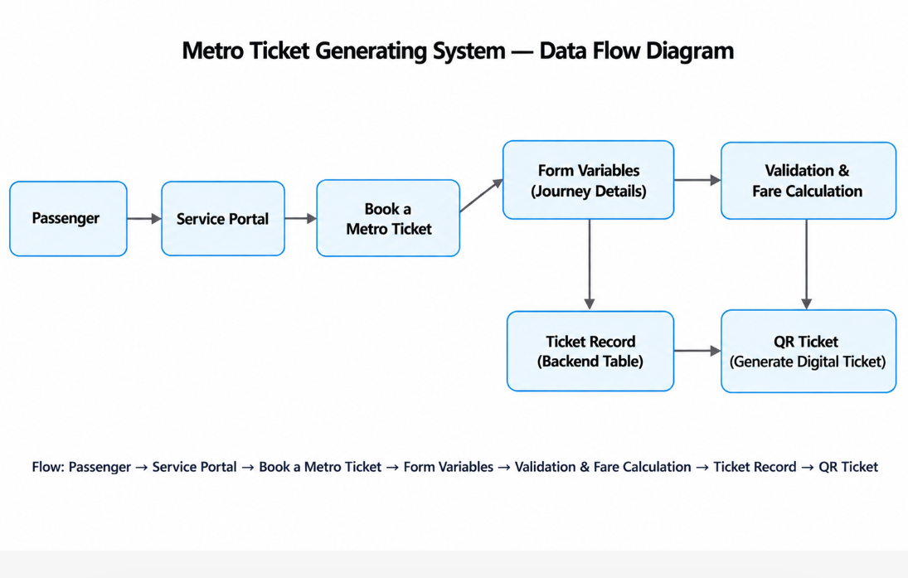
Figure 1: High-level Metro Ticket Generating System data flow.

User Stories
User Type | User Story | Acceptance Criteria | Priority
Passenger | Open the Service Portal and find the metro ticket service. | Book a Metro Ticket item is visible and accessible. | High
Passenger | Select starting and destination stations. | Valid station values can be selected. | High
Passenger | Select the journey type and number of passengers. | Journey type and passenger count are captured correctly. | High
Passenger | View the fare based on the selected route. | Fare is automatically calculated according to the configured route and journey type. | High
Passenger | Enter payment information when required. | Payment mode field appears according to the selected option. | Medium
Passenger | Submit the metro ticket request. | Request is created successfully with the entered booking details. | High
Passenger | Receive a digital QR ticket. | QR code is displayed after ticket submission for verification. | High
Administrator | Maintain metro station and ticket configuration. | Station records and catalog configuration can be maintained. | Medium
Administrator | Control access to metro booking data. | Unauthorized users cannot directly access restricted backend data. | Medium

